LAB 21
File Inclusion
1. Introduction
In PHP programming there are include, require, require_once, include_once commands that allow the current file to call to another file. Depending on the security level of the server, the attacker could include the file on the server itself (include local) or include it on another machine (include remote). The intent of the attacker is to run system functions and collect sensitive information of the system. All work on the attacker can be achieved when the web shell is run
2. Preparation
- Computer running windows operating system. Require to disable the firewall on the system.
- The source code management mysql - phpmyadmin
https://www.phpmyadmin.net/downloads/
- XAMPP download by following link:
https://downloadsapachefriends.global.ssl.fastly.net/xampp-files/5.6.31/xampp-win32-5.6.31-0-VC11-installer.exe?from_af=true
- DVWA download the following link:
http://www.dvwa.co.uk/
- The browser software chrome, firefox 10.0, 7zip, Notepadd ++.

3. Implementation steps

- Turn on xampp and go to 192.168.0.103/DVWA login with user: admin. Pass: password 192.168.0.103 here is ipv4 machine running dvwa on localhost

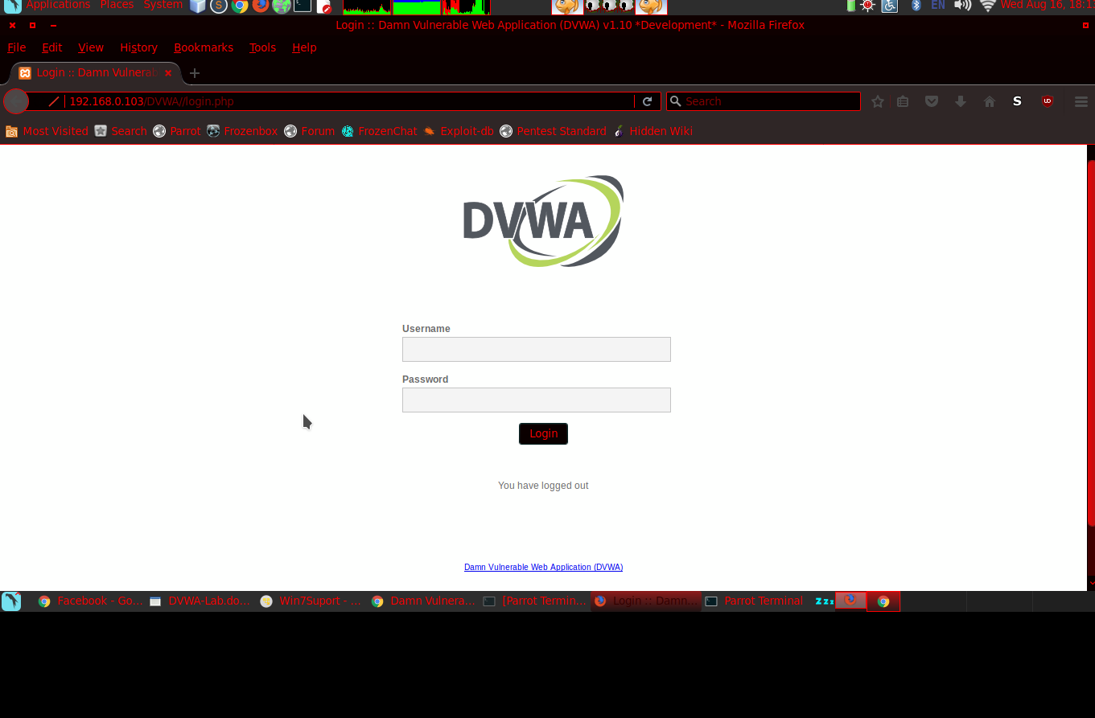
- Login complete, we choose dvwa security> Select low and submit

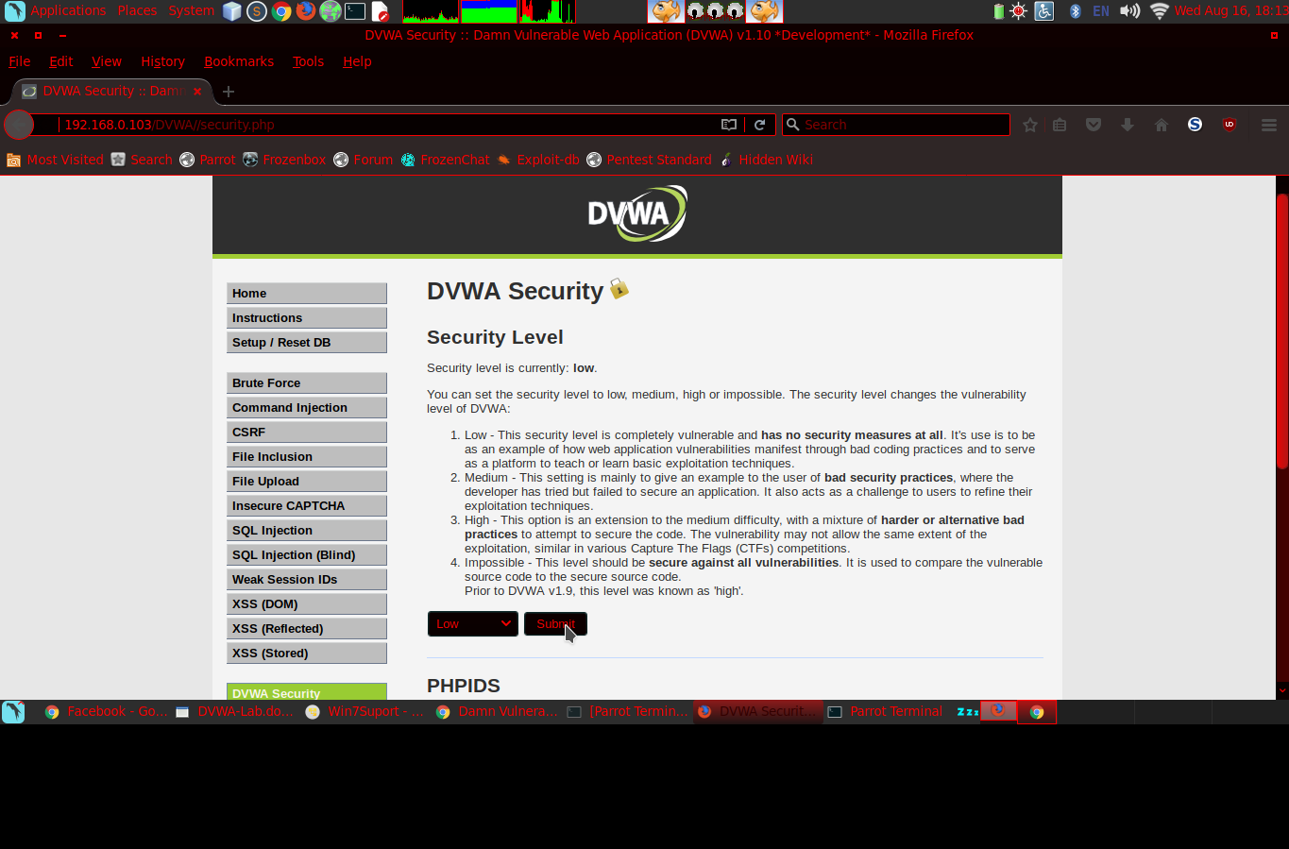
- Click to File Inclusion
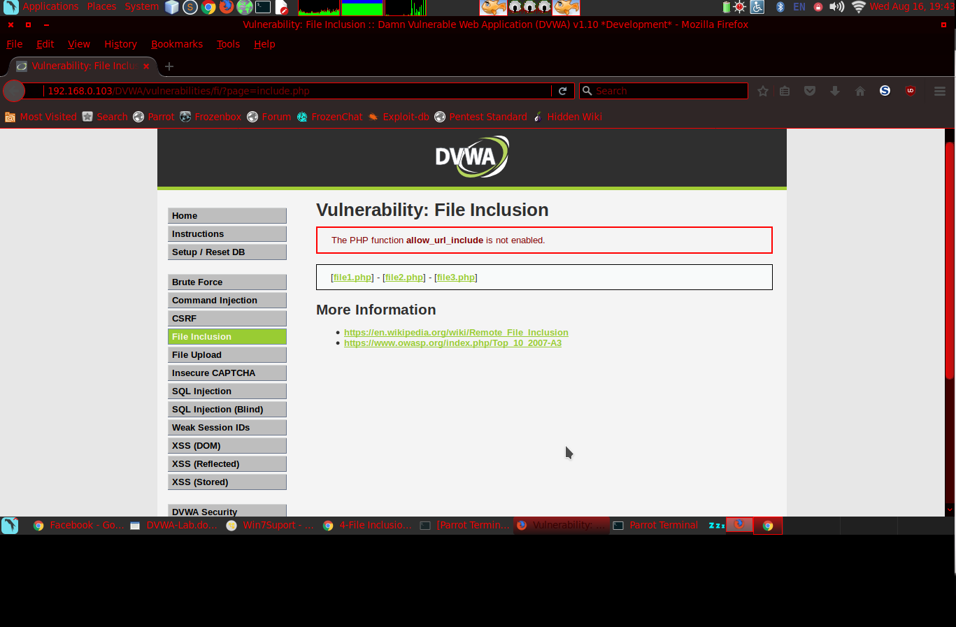
- Click file1.php
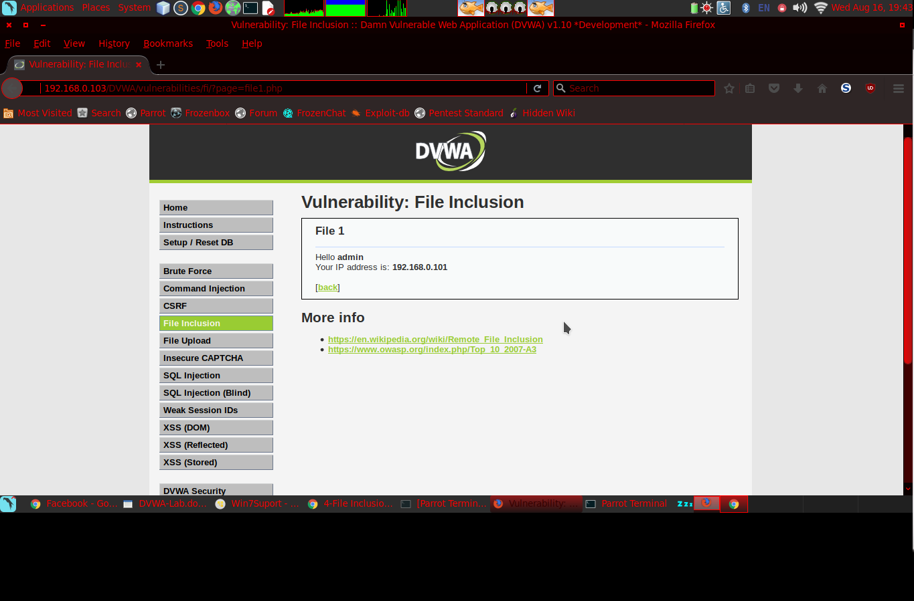
- Back and Click file2.php
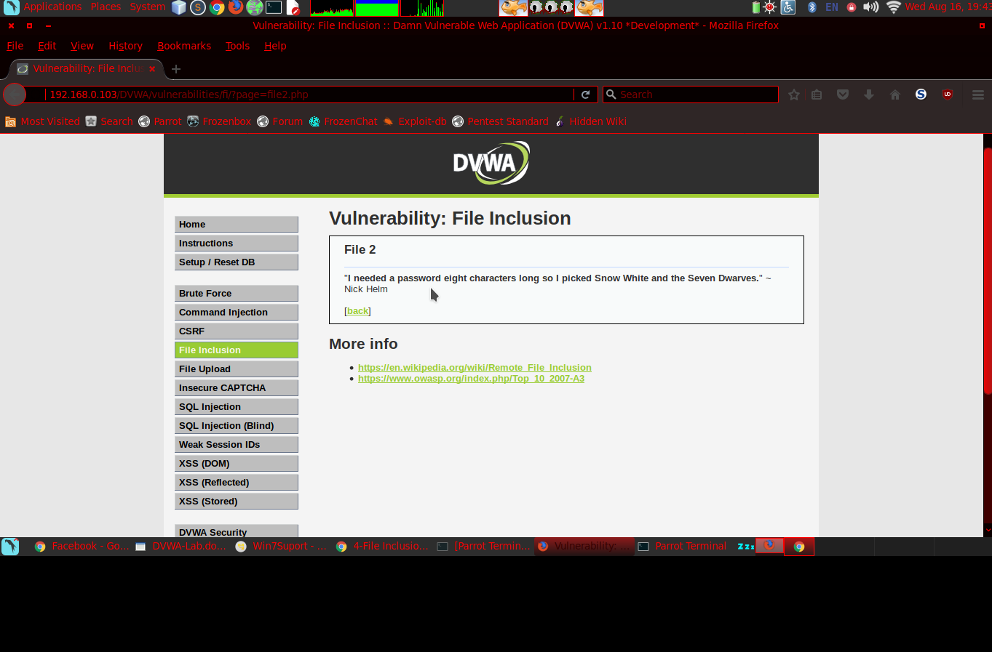
- Back and click file3.php
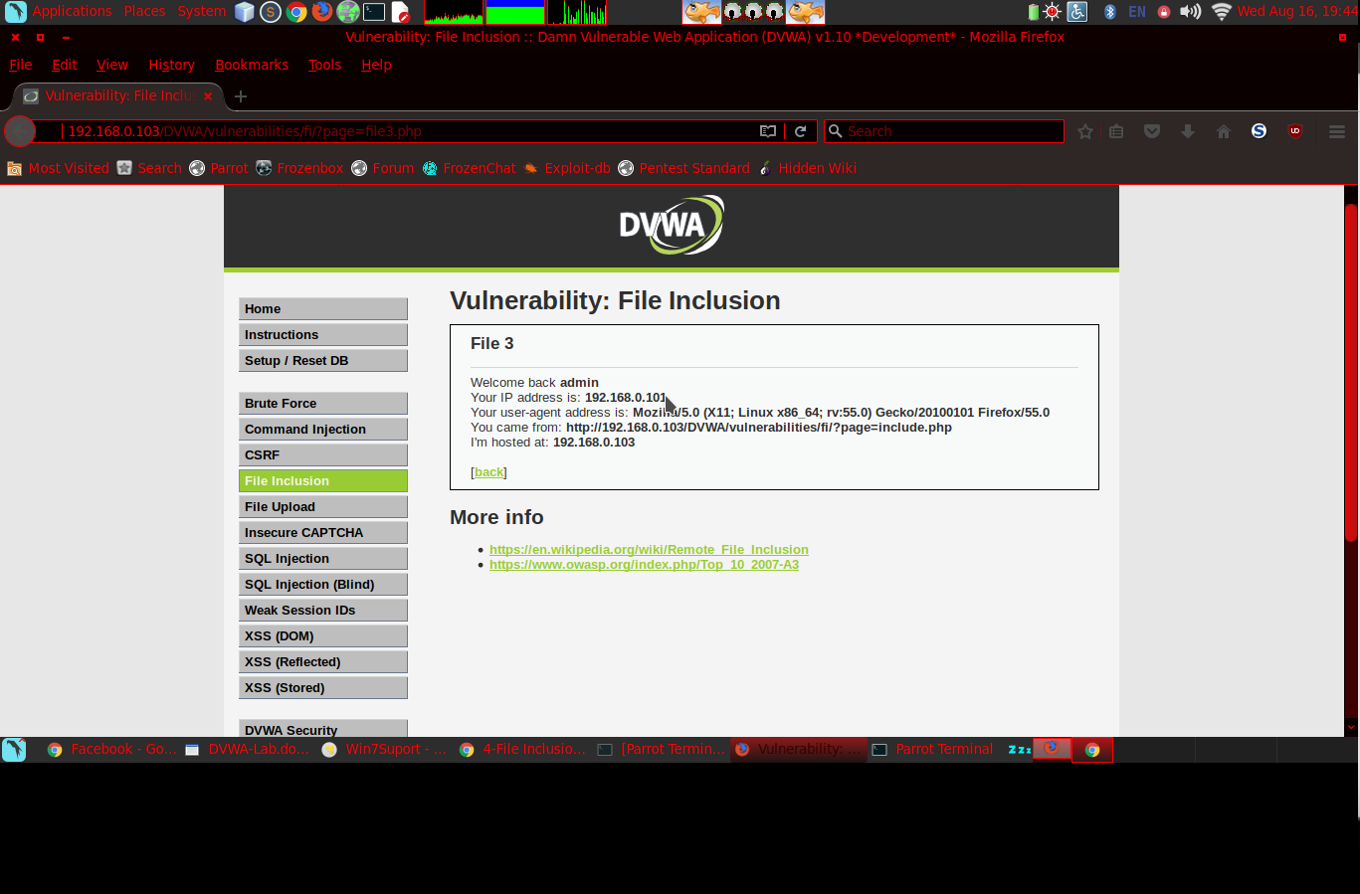
- Open the second tab of your browser, go to 192.168.0.103/DVWA/robots.txt
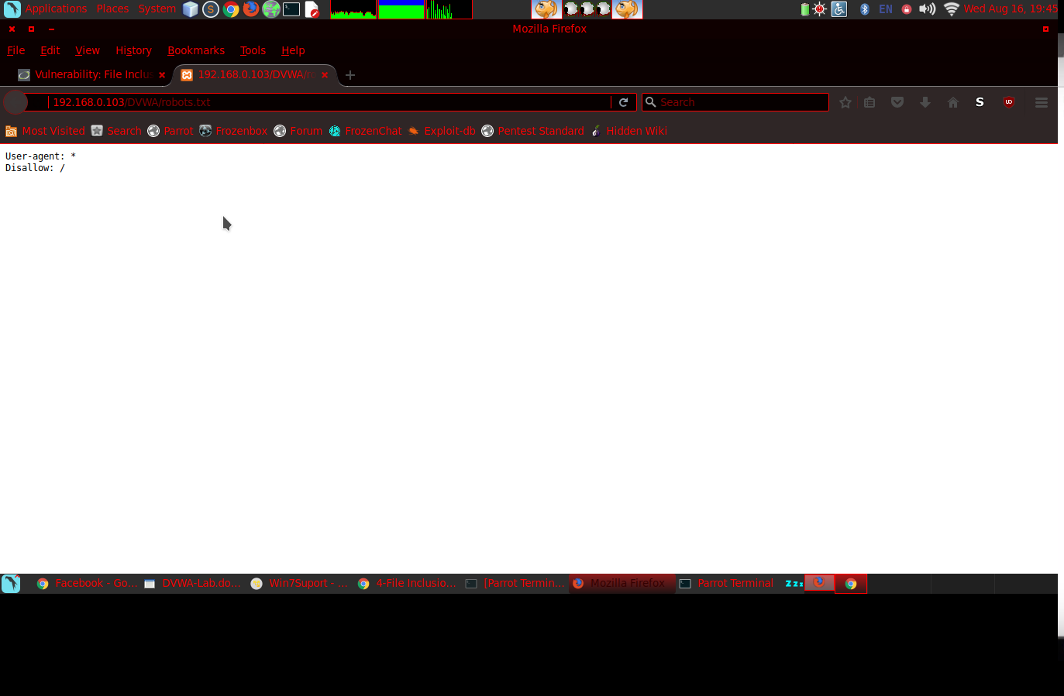
- Back to tab 1 revise link after the "=" we insert: .. \ .. \ robots.txt
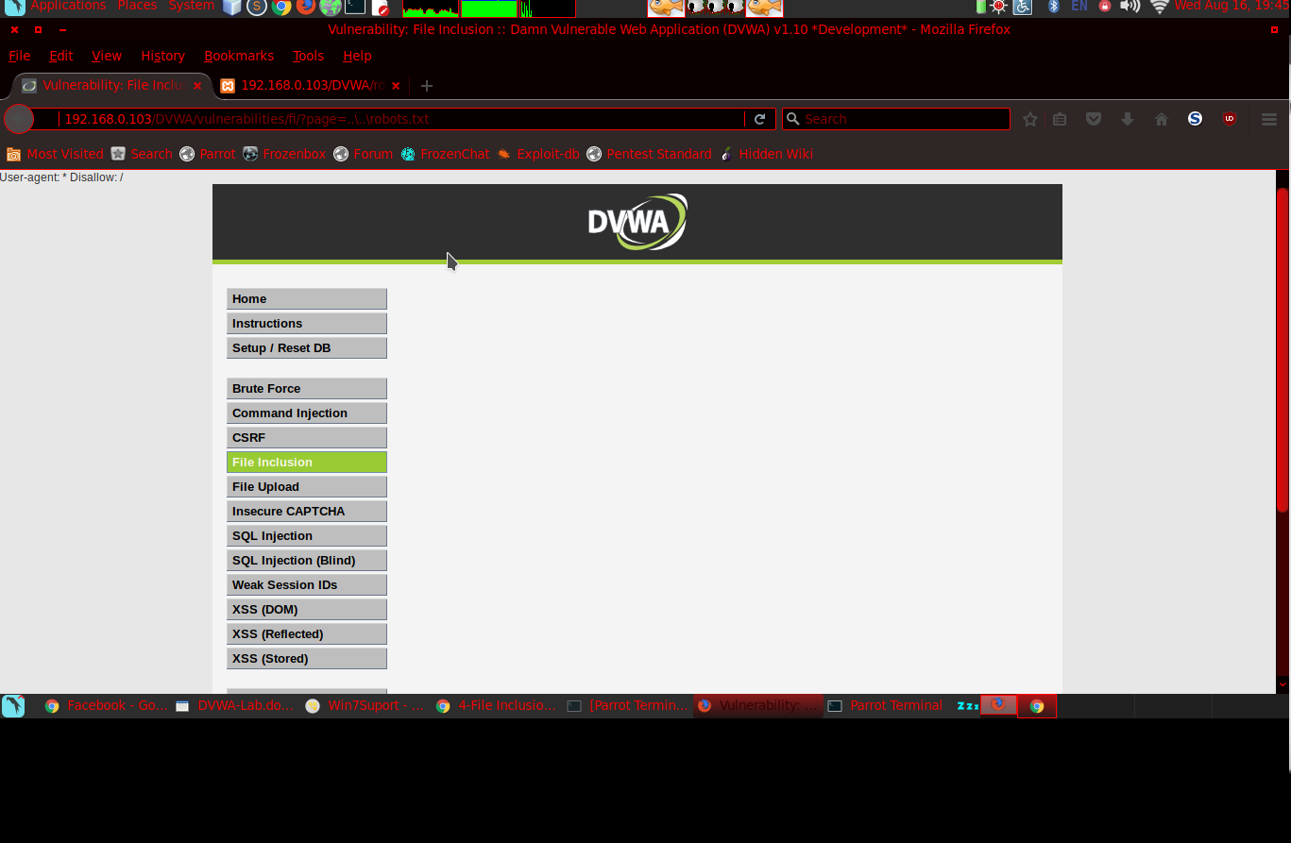
- To tab 2, replace robots.txt with phpinfo.php
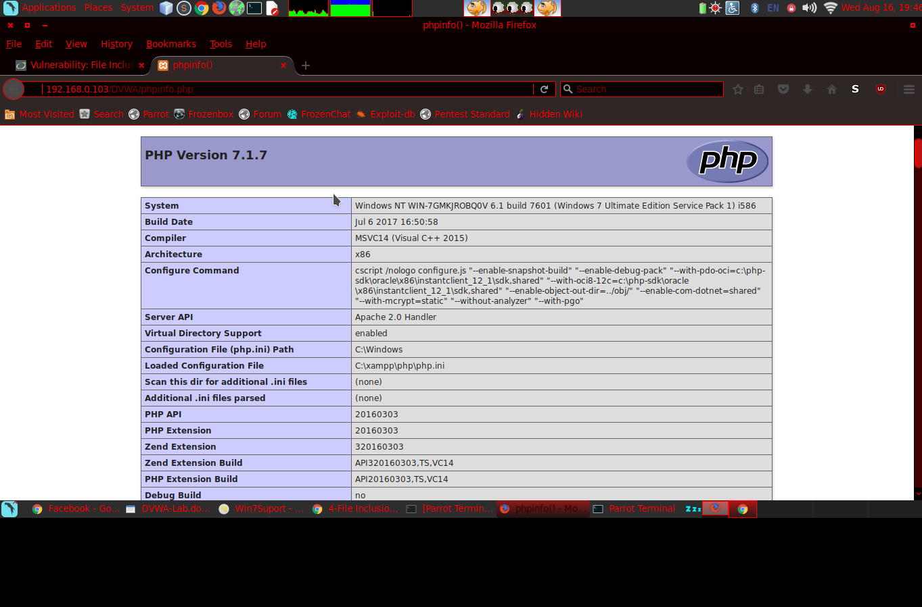
- Back to tab 1, we edit robots.txt to phpinfo.php and we see the same as tab 2
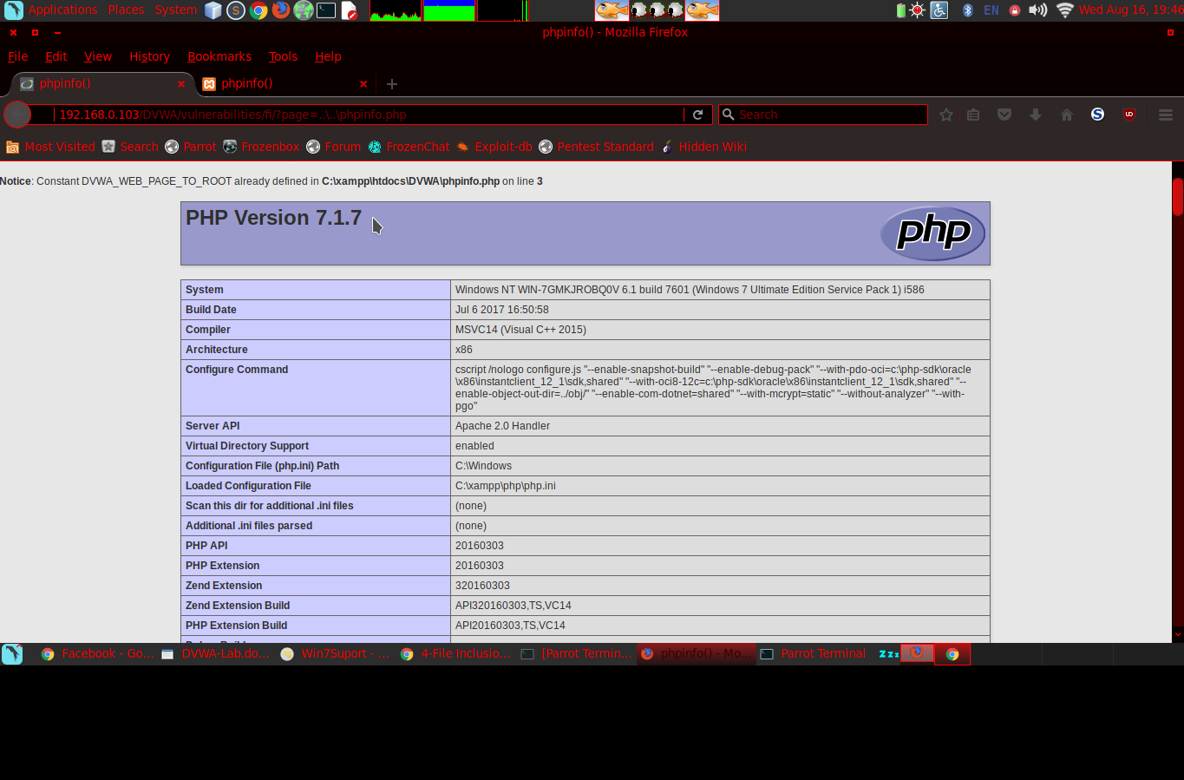
- In tab 1, edit the link after the sign "=" to: .. \ .. \ .. \ .. \ .. \ bootmgr we see this file is encrypted, we can not read
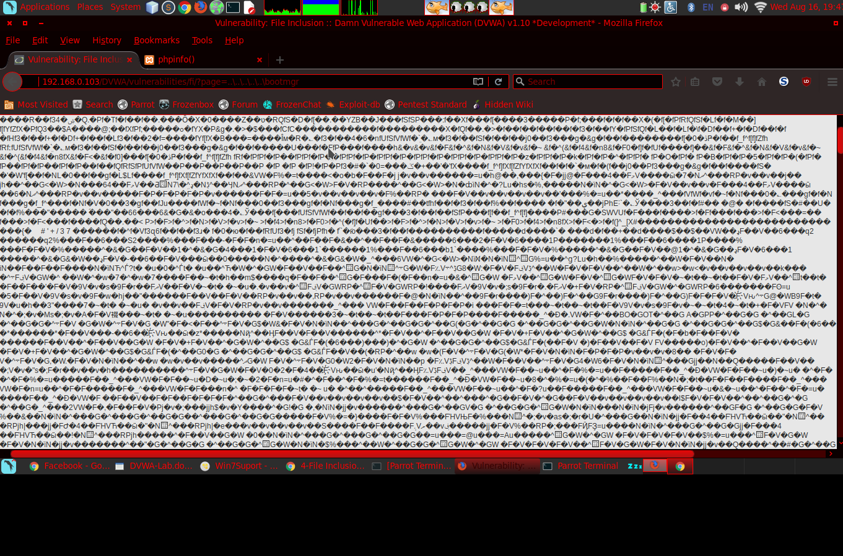
- Return to File Inclusion> Click DVWA secuirity select Medium and submit
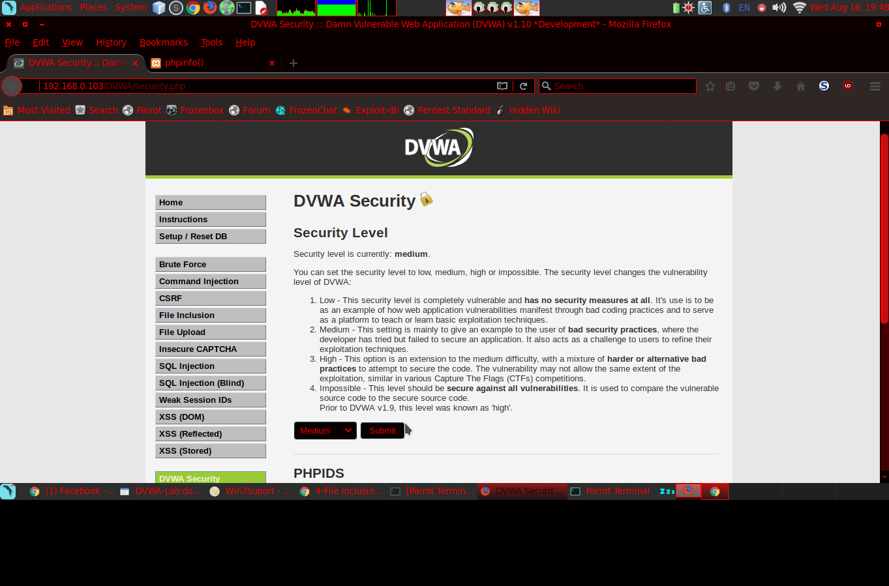
- Click File Inclusion
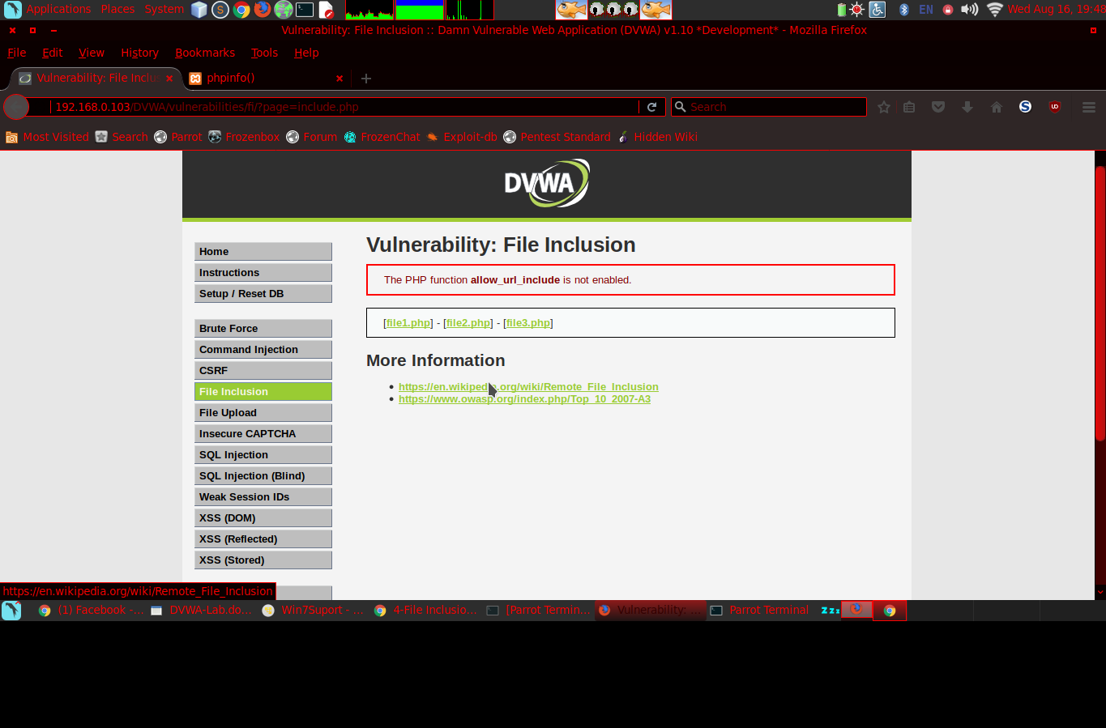
- Click file1.php
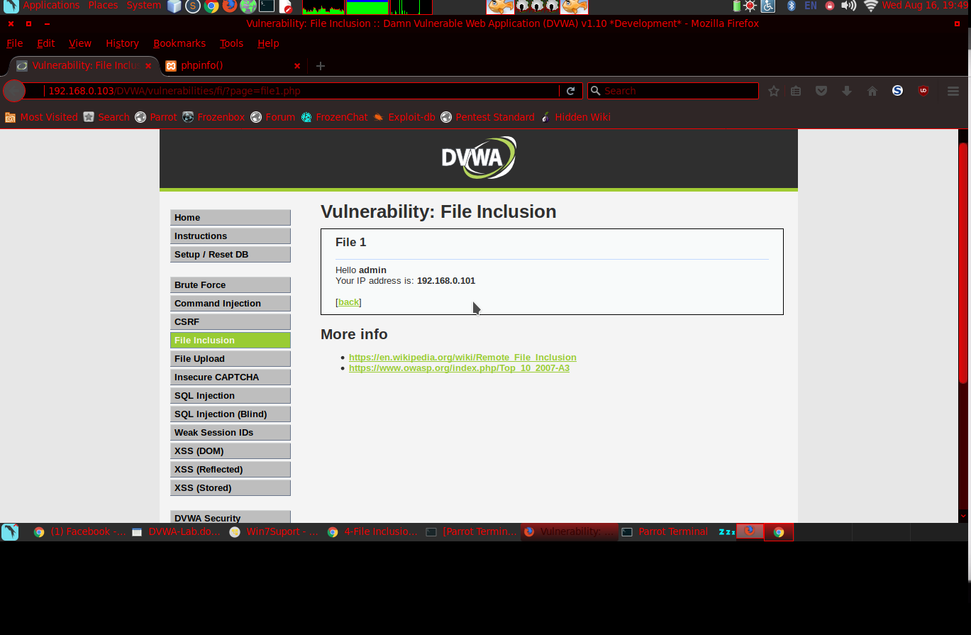
- Edit the link, delete file1.php on the link, replace .. \ .. \ phpinfo.php and we see the file info version php
